**Carbon Reduction Plan**

**Supplier name:** Recruit2schools Ltd

**Publication date:** 10/6/2024

**Commitment to achieving Net Zero**

Recruit2schools Ltd is committed to achieving Net Zero emissions by 2050.

**Baseline Emissions Footprint**

Baseline emissions are a record of the greenhouse gases that have been produced in the past and were produced prior to the introduction of any strategies to reduce emissions. Baseline emissions are the reference point against which emissions reduction can be measured.

|  |  |
| --- | --- |
| **Baseline Year: 2023** | |
| **Additional Details relating to the Baseline Emissions calculations.** | |
| **Baseline year emissions:2023** | |
| **EMISSIONS** | **TOTAL (tCO2e)** |
| **Scope 1** | 0.8 tCO2e |
| **Scope 2** | 0.4 tCO2e |
| **Scope 3**  **(Included Sources)** | 2.5 tCO2e |
| **Total Emissions** | 3.73 tCO2e |

**Current Emissions Reporting**

|  |  |
| --- | --- |
| **Reporting Year: 2024** | |
| **EMISSIONS** | **TOTAL (tCO2e)** |
| **Scope 1** | 0.8 tCO2e |
| **Scope 2** | 0.4 tCO2e |
| **Scope 3**  **(Included Sources)** | 2.2 tCO2e |
| **Total Emissions** | 3.4 tCO2e |

**Emissions reduction targets**

In order to continue our progress to achieving Net Zero, we have adopted the following carbon reduction targets.

We project that carbon emissions will decrease over the next five years to 2.5 tCO2e by 2025. This is a reduction of 32.43%

These calculations show that there has been a reduction of 0.3 tCO2e in total emissions from 2023 to 2024, **which corresponds to an approximately 8.11% decrease in emissions.**

We project that carbon emissions will decrease over the next five years to 2.5 tCO2e by 2025. This is a reduction of approximately 32.43% from the baseline year emissions.

**Carbon Offset Initiatives**

* **Tree Planting:** To further offset our carbon footprint, we have purchased 50 trees for planting. It is estimated that these trees will sequester approximately **1.0885 metric tons of CO2e (tCO2e) over one year** annually, contributing to our emissions reduction efforts**.**

**Progress against these targets can be seen in the graph(s) below:**

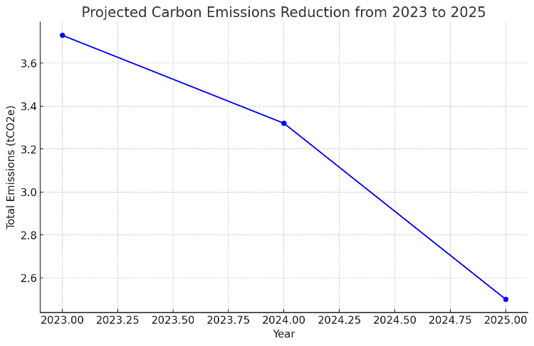

**Carbon Reduction Projects**

**Completed Carbon Reduction Initiatives**

* Adoption of LED/PIR lighting controls.
* Reduction in company travel and flights by promoting virtual meetings.
* Electrification of the company fleet.
* Continuation and enhancement of recycling programme

The carbon emission reduction achieved by these schemes equates to a reduction of 0.3 tCO2e, an 8.11% reduction against the 2023 baseline.

**Future Measures**

* Further improvements in building insulation.
* Increasing the use of renewable energy sources.
* Expanding the use of electric vehicles within the fleet.
* Extension of and Implementing comprehensive recycling programs.

**Declaration and Sign Off**

This Carbon Reduction Plan has been completed in accordance with PPN 06/21 and associated guidance and reporting standards for Carbon Reduction Plans. Emissions have been reported and recorded in accordance with the published reporting standard for Carbon Reduction Plans and the GHG Reporting Protocol corporate standard.

Scope 1 and Scope 2 emissions have been reported in accordance with SECR requirements, and the required subset of Scope 3 emissions have been reported in accordance with the published reporting standard for Carbon Reduction Plans and the Corporate Value Chain (Scope 3) Standard[1].

This Carbon Reduction Plan has been reviewed and signed off by the board of directors.

**Signed on behalf of the Supplier:**

Patrick Drewe Phillips

Director

**Date:** 14/6/24

1. <https://ghgprotocol.org/standards/scope-3-standard>

   5<https://www.gov.uk/government/collections/government-conversion-factors-for-company-reporting>

   6<https://ghgprotocol.org/standards/scope-3-standard>